Discussion Report of Reading Assignment
Fengshuo,Yang/21216054

- My discussion thread
- Topic Situation(Posted Nov 15)
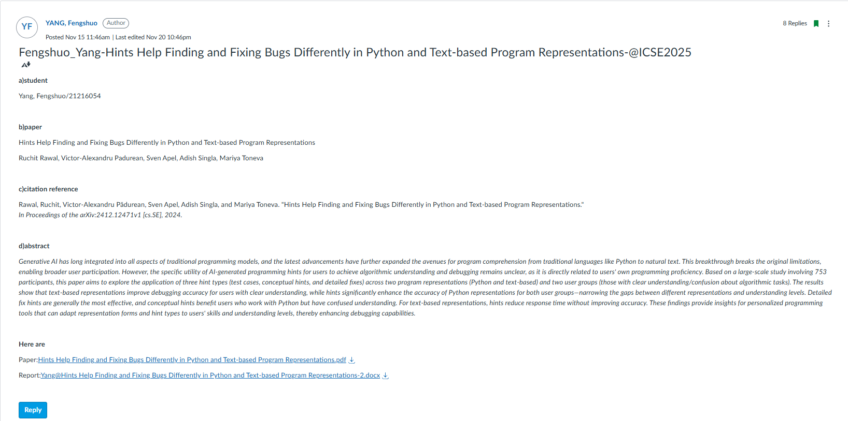

- comments and responses
- by QI, Ivy
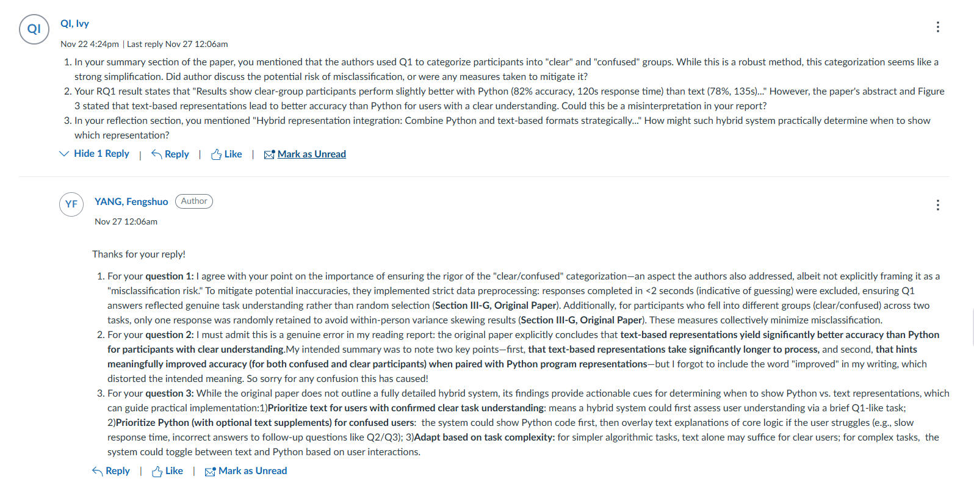
- by WU, Weiwei
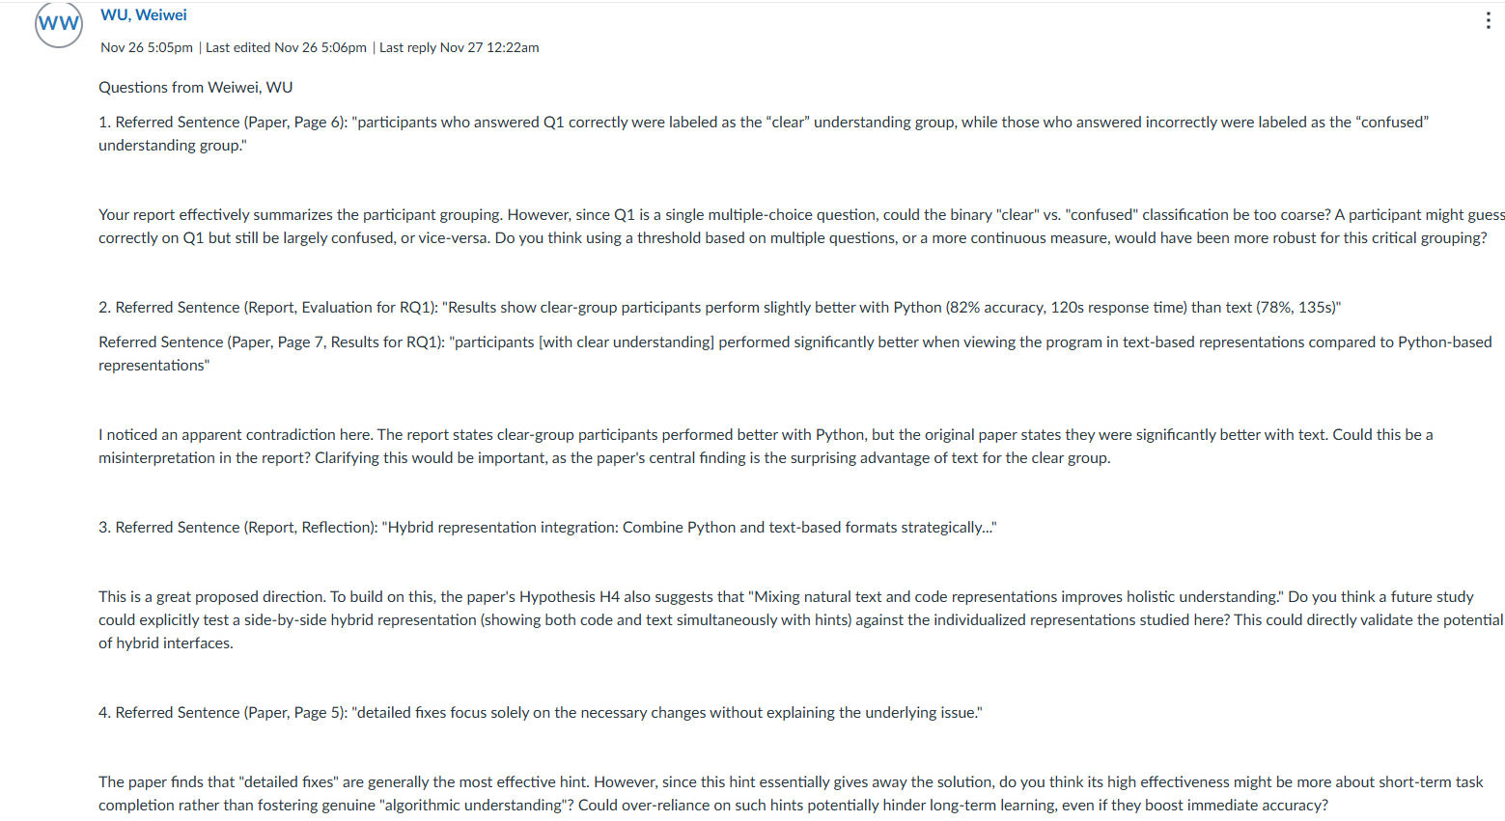
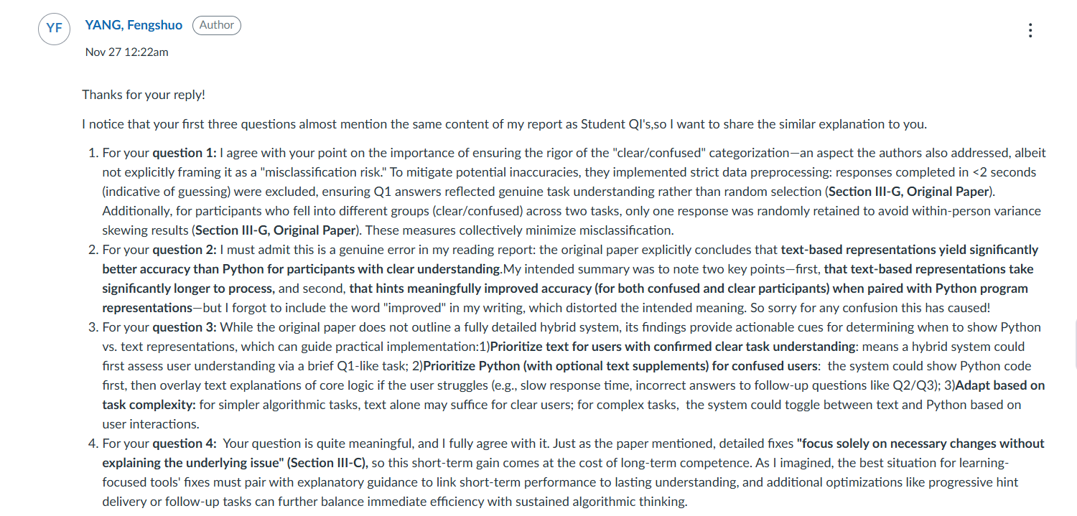
- by SHI, Haokun
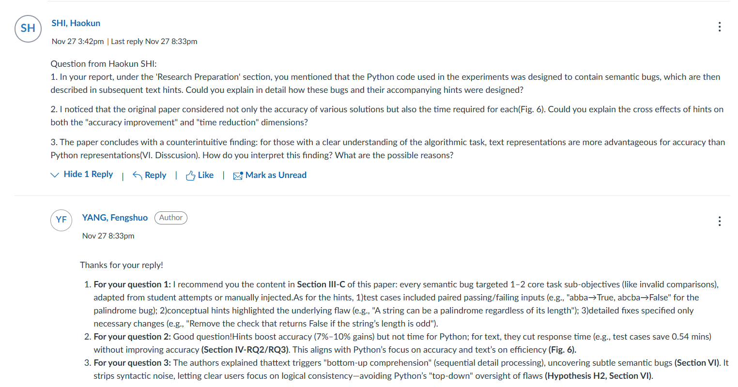
- by LIU, Haoming
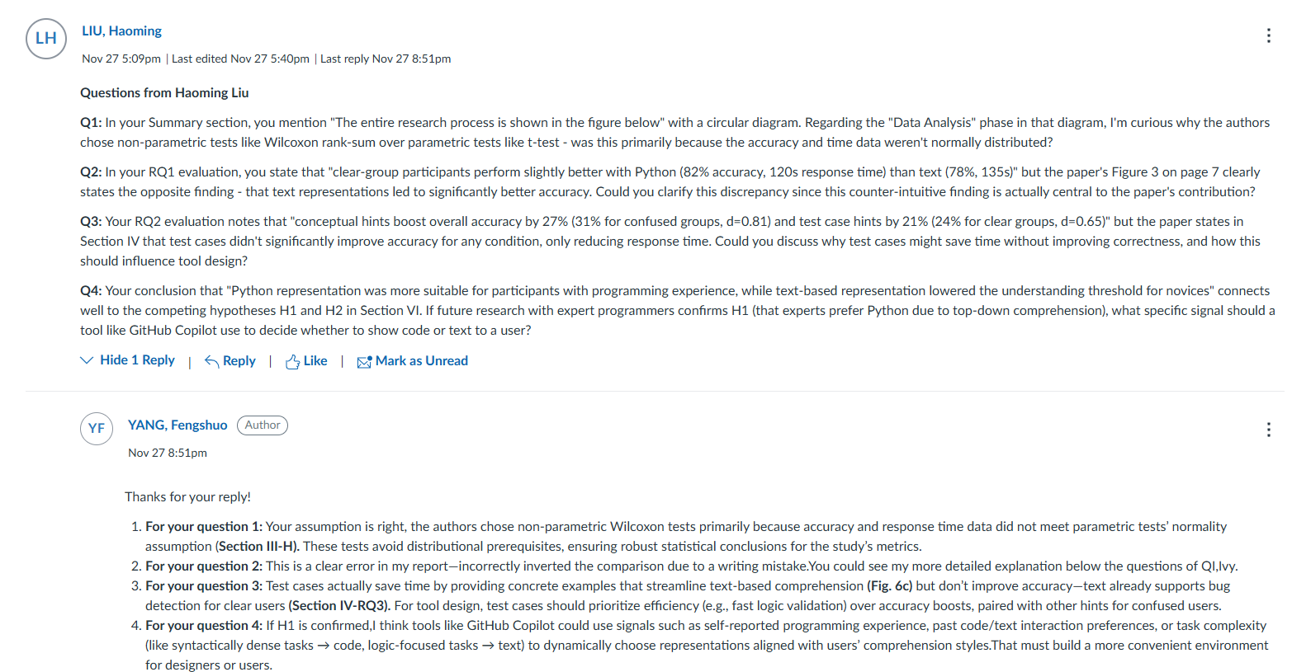

- Peer Review Report
Report  Author | P1  (Fluency) | P2  (Clarity) | P3  (Insights) | P4  (Reflection) | P5  (Response)
Zhang Zhihao | 5 | 4 | 4 | 5 | 5
For fluency: this report’s topic is easy to comprehend, and its expression is also comprehensive yet concise.

For clarity: this report provides a thorough explanation of the original paper’s framework, yet it may easily confuse readers regarding certain key details. In particular, while the report mentions the names of five prompting techniques- zero-shot, few-shot, chain-of-thought, critique, and expert,but it fails to clarify their differences.

For insights: while the rationale for selecting the target paper in this report lacks sufficient persuasiveness, its summary of the evaluation methods is remarkably thorough.

For reflection: the report supplements the explanation of each RQ with experimental result figures, and concludes by highlighting a key breakthrough of the original paper: advanced prompting techniques do not necessarily work better than simple zero-shot prompting.However, the report lacks in-depth divergence and discussion on this argument.

For the quality of response: the reporter provided high-quality responses to the comments, elaborating in detail on the lack of detailed demonstrations and examples in the original report that I raised in my feedback.

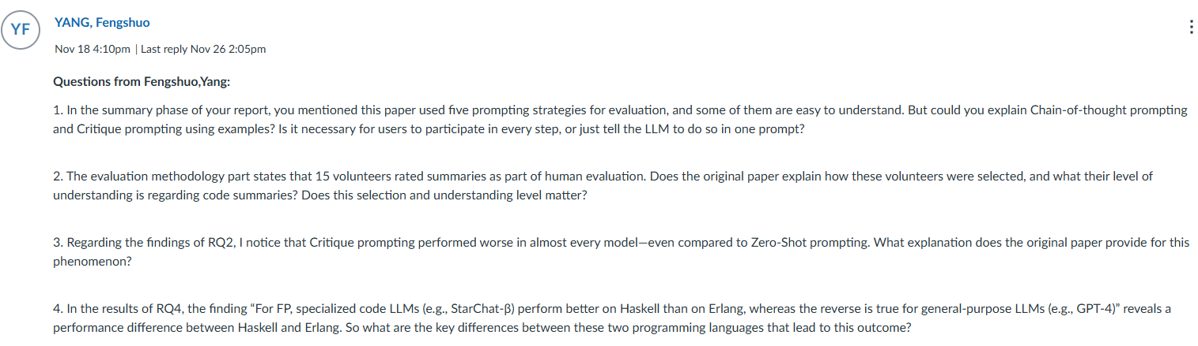
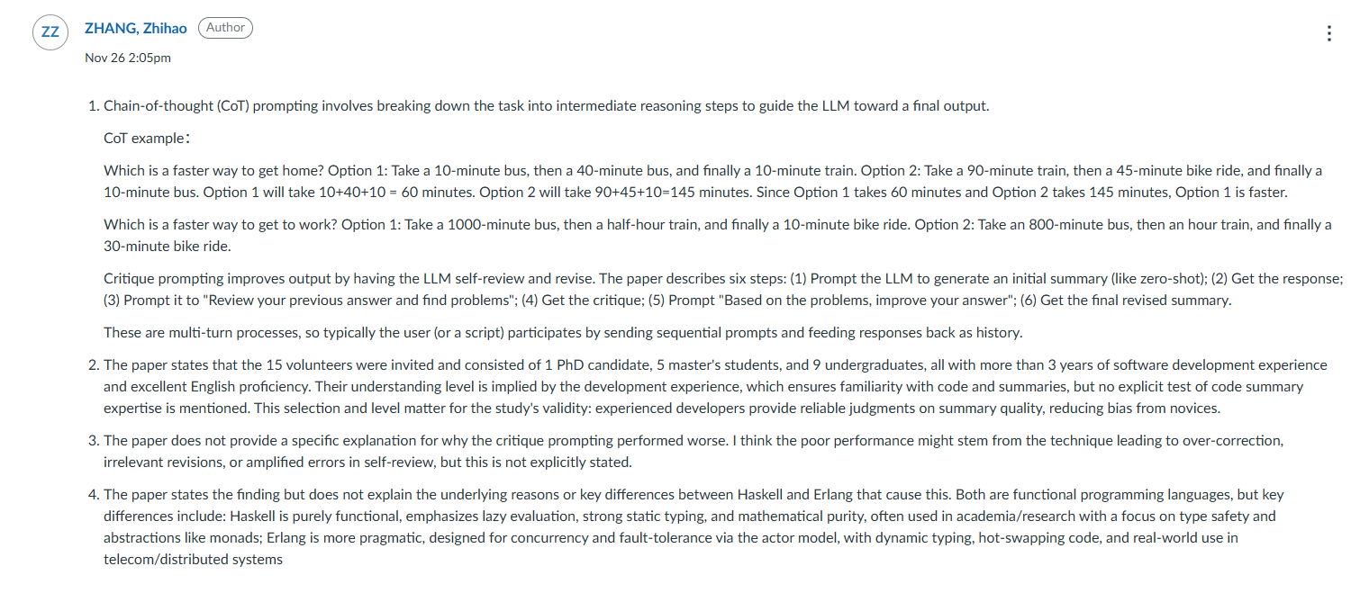

Qiu Zhangxizi | 5 | 3 | 4 | 3 | 5
For fluency: this report’s topic is easy to comprehend, and its expression is also comprehensive yet concise.

For clarity: this report lacks in-depth elaboration on key technologies and is overly concise in content. For instance, regarding the eight types of data noise and three categories of filters, it fails to mention their detailed classifications or complete architectures. Consequently, the report is unable to fully demonstrate the core methodologies of the original paper.

For insights: the reporter has provided an good summary of the original paper's efficiency, innovation, and rigor.

For reflection: the report presents the experimental results of the original paper in meticulous detail, yet it lacks discussions on the underlying causes and in-depth reflections. Consequently, readers can only passively absorb this information rather than following the original paper’s reasoning.

For the quality of response: the presenter provided extremely detailed responses to the comments, citing content from the original paper and effectively addressing the issues raised therein.
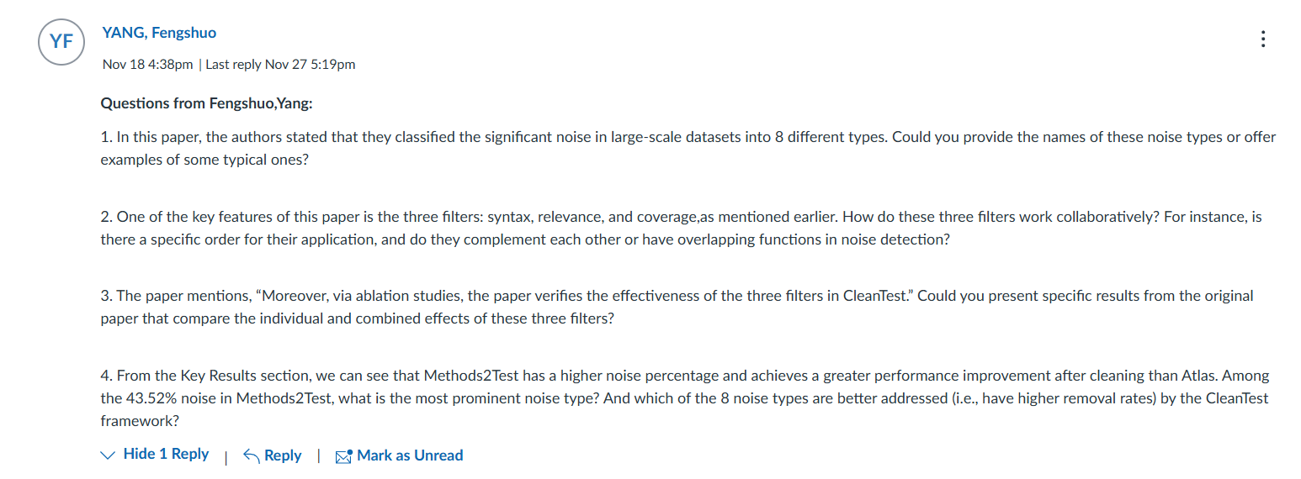
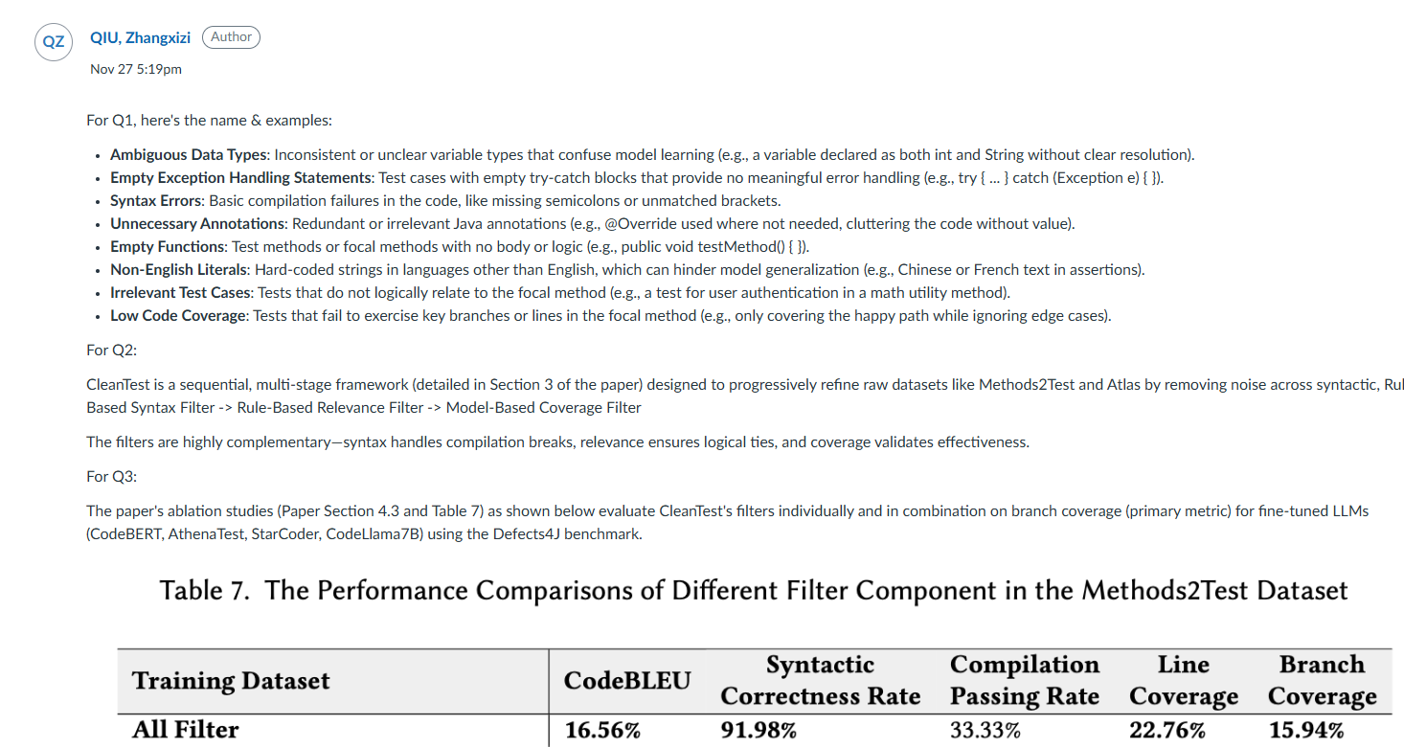

Zheng Bowen | 5 | 5 | 4 | 4 | 5
For fluency: this report’s topic is easy to comprehend, and its expression is also comprehensive yet concise.

For clarity: though lacking a flow chart, this report presents the research methodology of the original paper in an extremely intuitive manner through textual descriptions. Notably, the two terms "navigator" and "driver" accurately encapsulate the core responsibilities of the different agents.

For insights: by contrast, the content in this section of the report is not particularly persuasive and fails to fully reflect the advantages of the original paper.

For reflection: the report’s presentation of the RQ is exceptionally comprehensive, incorporating both clear figures/tables from the original paper and extensive textual explanations. Unfortunately, the final part of “reflection discussions” are somewhat insufficient.

For the quality of response: the presenter provided extremely detailed responses to the comments, citing content from the original paper and effectively addressing the issues raised therein.

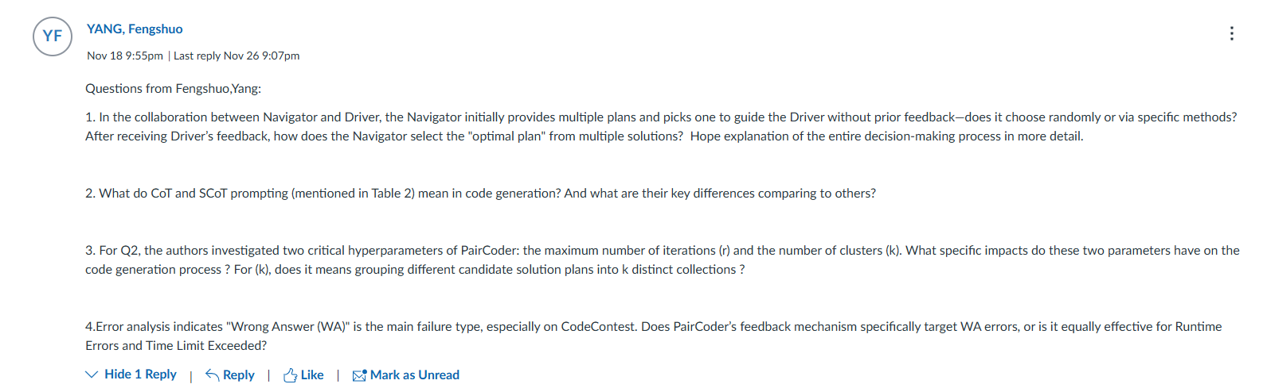
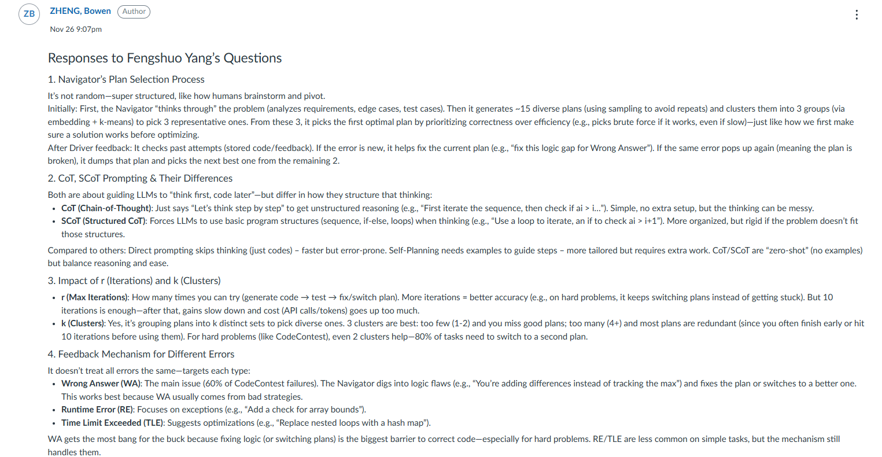

Zhu Ziyu | 5 | 5 | 4 | 5 | 4
For fluency: this report’s topic is easy to comprehend, and its expression is also comprehensive yet concise.

For clarity: the report elaborates in detail on the experimental validation methods for each RQ, with efficient support from the data in the original paper.That makes the purpose of designing each method much clear.

For insights: the research orientation of the original paper effectively summarizes the generalizability of code in the machine learning field. However, the report still lacks discussions on whether the paper possesses innovative value.

For reflection: the report’s presentation of the RQ is exceptionally comprehensive, incorporating both clear figures/tables from the original paper and extensive textual explanations.The result comparisons presented in each figure/table are remarkably striking.

For the quality of response: the reporter’s responses lack citations from the original paper, resulting in much of the content being unsupported or disconnected from the original paper.
